TO: Benjamin Bushong, Professor

FROM: Sayem Lincoln, John Townshend, Joshua Schwimmer.

DATE: April 29, 2020

SUBJECT: Carbon Emission Information and Prediction App

Climate change has been known to vary throughout the long history of our planet, but only in our recent history has it become a concern. The effects and ramifications of climate change are numerous and debatable; many famous figureheads around the world seem to have an input on what they believe to be true about climate change, however, beliefs are not as concrete as exploring the data for yourself. Built for common consumption and ease of understanding, an app which presents continuously updated data and visualizations will provide the knowledge necessary to be informed about climate change. Here we present six different visualizations which will make up the app, should the proposal be granted further funding.

**Carbon Dioxide Concentration Timeline**

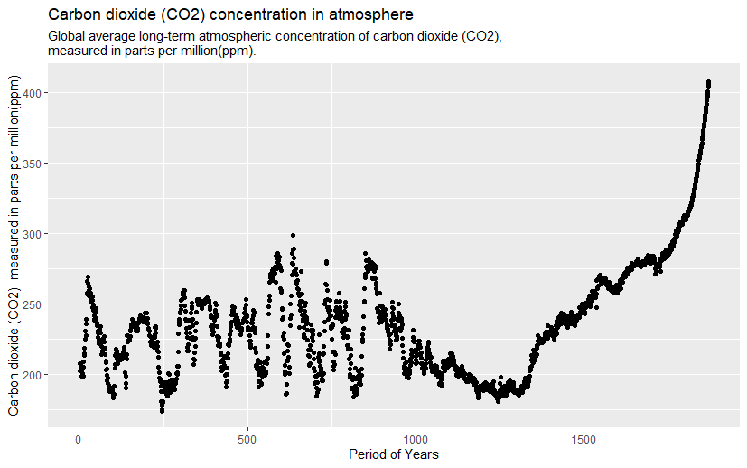

To begin, the simplest plot (pictured above) is a visualization of the carbon dioxide present in the atmosphere measured in parts per million starting roughly 2000 years ago at year 0 A.D. and ending at the present. The visualization uses average values of carbon dioxide concentration for each year and plots them using a dot for each year. This type of graph is understood intuitively and presents perhaps some of the most useful information that an informative app like this could offer: the facts. Data like this, especially presented over such an extended time frame, shows you what carbon dioxide concentrations have been and where they seem to be going. Further analysis on prediction is reserved for later visualizations, but one can infer from this graph that in the past 200 years or so, carbon dioxide concentrations have increased to about double of even the highest peak concentrations of the past. Peaks and troughs from 0 A.D. to about 1750 A.D. appear to fall within comparable minimums and maximums of each other most likely due to glacial advance and retreat. This phenomenon has been known to occur about 7 times throughout history until the modern climate era which we live in today, meaning that we should see about 7 peaks in the data, which we do until the present. This verifies the accuracy of our data with at least one other source, thus improving the external reliability of the information.

**Annual Carbon Dioxide Emission**

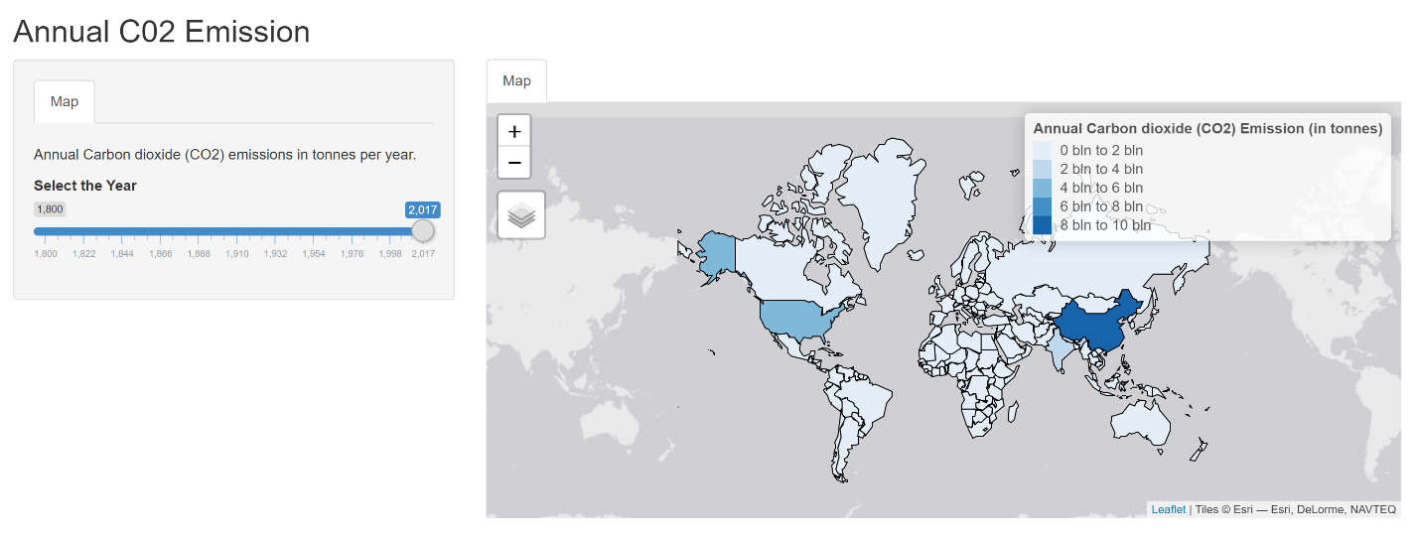

If consumers seek specific information about year to year emission of a certain country rather than a general timeline on a global scale, this interactable figure provides such information. A slider is provided to select from the year 1800 to 2017 and is set to 2017 for demonstration purposes. Additionally, a heat map of the world is provided along with color coding for each country which indicates more emission with darker shades of blue. This allows a deeper look at where the emissions that cause the spike in the previous visualization come from and about where they started from as far back as the industrial revolution. As expected, the map shows us that some of the most industrialized countries in the world have the greatest emission, like the Unites States and China. In the full version of the application, exploring the rise and fall of countries’ emissions through time will be possible rather than a set demonstration value. 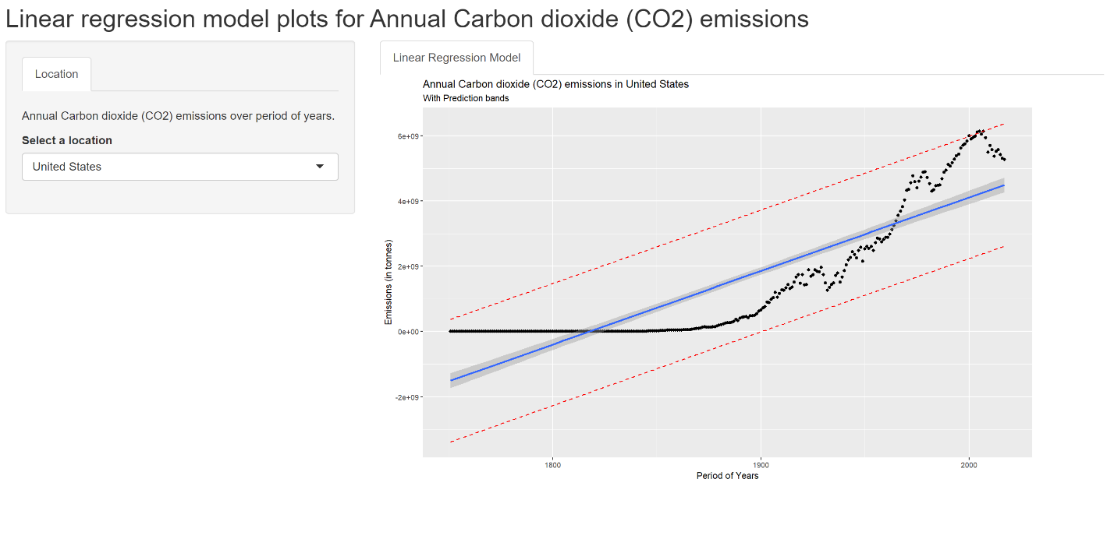

The figure depicted above is a linear regression model of a selected country’s emission over a period of more than 200 years. A drop-down menu is used to select a country, and like the previous part the provided graphic has been pre-selected for this demonstration to the United States. Each year’s average emission level is represented by a point on the graph. A line of best fit and prediction bands follows the trend of the selected country to show where the emission values will most likely fall in the future. These descriptors of the data show a relationship between emission level and time which in the example provided is a positive relationship for the United States.

**Forecast of Temperature Change**

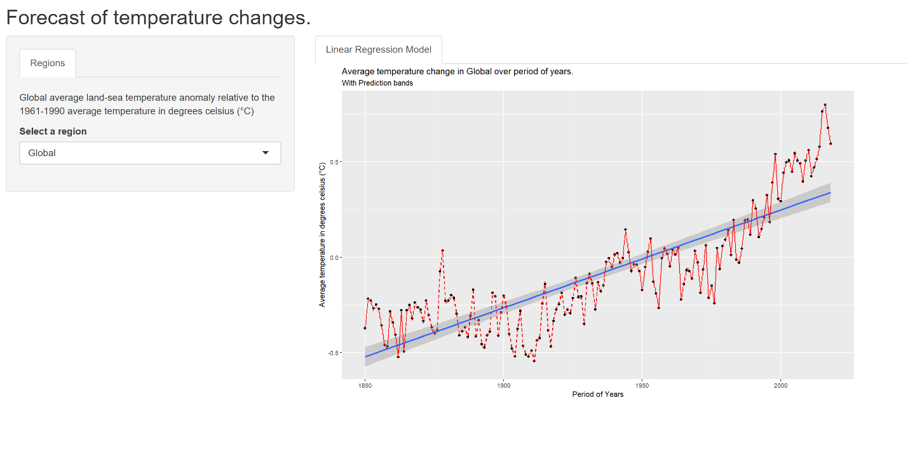

Another important aspect of understanding climate change is being able to see the impact of carbon dioxide emissions on temperature rather than only seeing graphs relating to emission or concentration. While information on emission and concentration is vital, witnessing a connection between those aspects of climate change and the everyday unit of degrees Celsius brings a more grounded perspective to the issue. The graph above allows drop-down menu selection between four regions: Northern hemisphere, southern hemisphere, tropical regions, and global. Currently selected for this demonstration is the global option. A linear regression model provides a line of best fit and prediction bands for temperature changes from 1850 to the present in relation to the average temperature between 1961 and 1990. Therefore, temperature below this average will be reported as lower temperature in comparison and above the average will be reported as higher temperature in comparison. Like most graphs shown, there is a positive correlation between time and impact of global warming or in this case temperature. While units on the Y-axis of this graph are only counted by half a degree Celsius (or .9 degrees Fahrenheit), the subtle increase in temperature over time is impactful. Our atmosphere is a very large volume of gas but is impacted by what we do; it is mechanically comparable to investing. A little money can go a long way given enough time, and so can the impact of emissions on our atmosphere. Worsening storms, flooding, and greater extremes in normal weather patterns are some of the felt impacts of such small changes, changes represented in the graph. With the selection options available, one can traverse the trends of the regions described previously and learn where the temperature is changing the most and where it is trending towards for the future.

**Per-Capita Carbon Dioxide Emission**

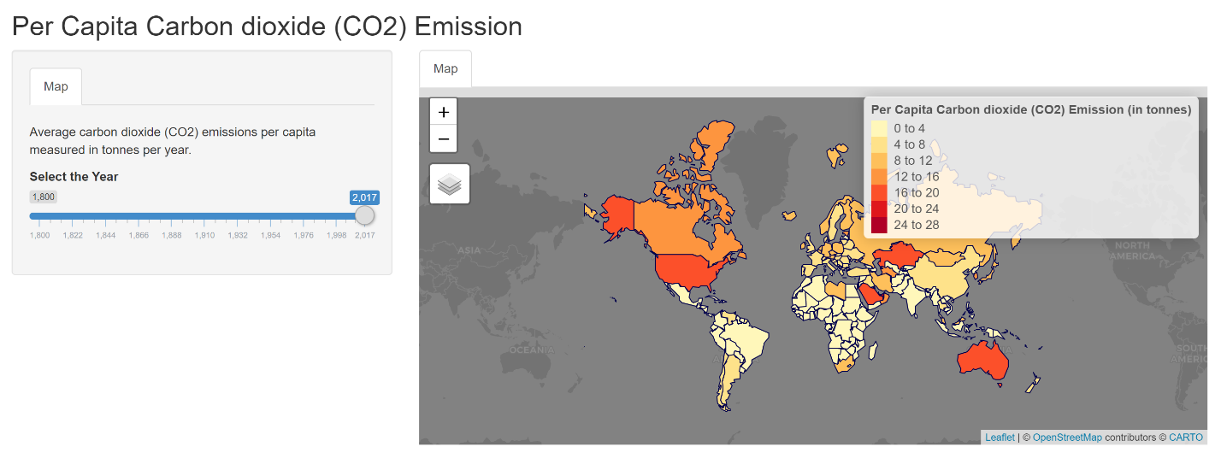

Practically, it is hard to say what just one person can contribute to the global scale of climate change, but this section seeks to provide a general estimate. Like the second visualization, this graphic presents another heat map and year selection slider, this time in the context of per capita carbon dioxide emission in metric tons per year for each country. Again, the slider has been set to 2017. All over the world, different countries host vastly different lifestyles, all which require different resources to maintain. For more industrialized countries, cars, electricity, hot water, and other mechanisms which contribute to carbon dioxide emission are essential to day to day life. This means that members of these countries contribute more to climate change than areas that rely less on these mechanisms, which is a dynamic that can be explored in the graphic. This data raises awareness of how much carbon dioxide emitting tools an individual will use in comparison to others on a general scale with the unit of metric tons. Cycling through the years with a slider can provide additional context for when a country started to become more industrialized. On the example map, the United States, Kazakhstan, Saudi Arabia, and Australia appear to have the highest rates of CO2 use per capita, and therefore make the most difference per individual.

**Production Versus Consumption based Carbon Dioxide Emission**

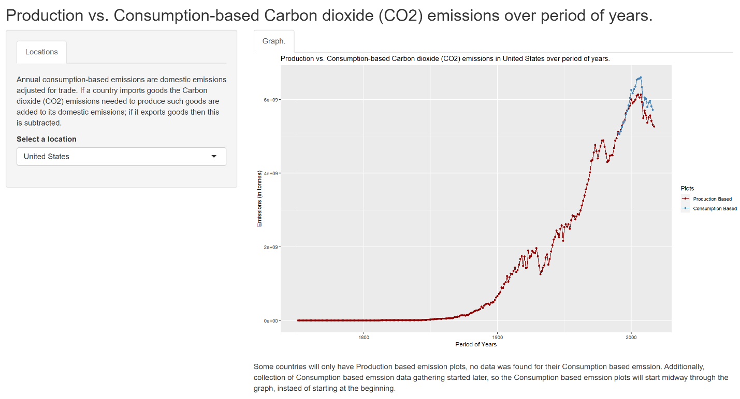

Lastly, this graph depicting production versus consumption-based emissions further specifies the carbon dioxide emission regarding the imports and exports of a specific country, again selectable by a drop-down menu. The United States is selected as an example once again. Production and consumption are another level of emission to consider when a country’s emissions are studied. What this data seeks to explain is the effect of consuming, or importing, goods produces emissions and must be added to that country’s total emission measurement. Simply put, the more a country imports, the higher their consumption-based emissions will be. Additionally, if a country exports more than it imports, its consumption-based emission level will be subtracted from because that country is not using the good which it produced, rather, it is being used by another country. Production-based emissions only define what a country emits withing the space that the country has jurisdiction over. While this metric is more detailed than all previous representations of emission and concentration, it identifies what countries consume more than they produce. However, data on consumption-based emissions had started being gathered later in time than production-based emissions, and some countries are not accounted for at all. Data on this topic is new and will continue to grow in time as additional factors are considered and trade is more accurately accounted for in the realm of climate change impact. The example provided illustrates that in recent years, the United States has been adding to emissions when consumption-based data is represented, and is no surprise considering how many corporations outsource labor and production and import the product. While this business strategy is cost effective, it does leave other areas of the world to deal with the emissions that the United States benefits from. Analyses such as this are the reason that the well-presented data in this application can be practically useful.

**Conclusion**

The data and visualizations represented here aim to inform the public in an easy to understand manner of the effects and implications of climate change or global warming. Six visualizations including a carbon dioxide concentration timeline, annual carbon dioxide emissions by country, a linear regression for annual emission for a given country, a forecast of temperature changes, per-capita emissions, and production versus consumption based emissions capture many different angles of the issue so that the dimensions of climate change are represented for a deeper understanding of the topic. It is important to find the facts on such topics, so opinions are informed and progress over time is tangible and visible. Should this project be granted further funding, a publicly available application will be developed and hosted from a server with year to year updates on data and visualizations.